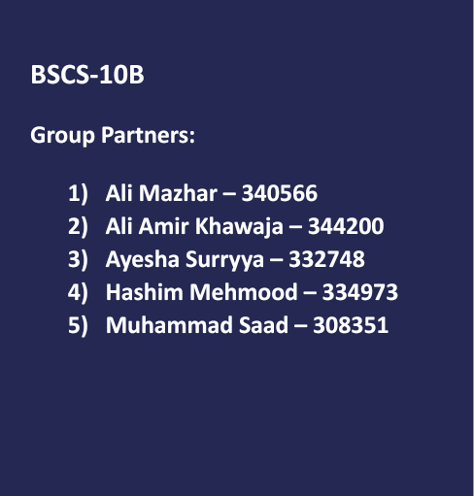



Contents

**Research Topic :** 2

**Problem Statement** 2

**Objective** 2

**Target Sample** 3

**Justification of Choosing the Sample** 3

**Justification for Data Collection Tool** 3

**Questionnaire Analysis:** 4

Age of the Respondents: 4

Frequency of Online Shopping During Sales 4

Motivation(s) to Shop Online on Sales 5

Purchasing Power and its Affect 5

The Regret after Buying 7

Pressure of Online Sales 7

Feelings to Buy More 8

Having Strategies not to Overspend 8

Discounted Products and Joy 9

Feelings after Buying at Online Sales 9

Comfort in Sharing personal Info 10

Reviews and their Influence 10

Payment Methods 11

The Sold Up Effect 11

Buying Over Budget 12

Website Appearance 12

Recommendations and their Effect 13

**Findings** 13

**Theoretical Frameworks** 14

**Annexure** 15

References 15

# **Research Topic :**

**“Psychological Factors Influencing People Who Buy Online During Mega Sales”**

# **Problem Statement**

There has been a significant increase in online shopping during the pandemic, with many retailers offering mega sales events to attract customers. The below data shows how much internet usage increased in Pakistan in just one year due to the pandemic:

* There were **76.38 million** internet users in Pakistan in 2020.
* The number of internet users in Pakistan **increased** by **11 million** (+17%) between 2019 and 2020.

This increase in access to hand-held devices and the internet means an increase in traffic generation and the potential increase in users for online selling platforms. These increases in demand and online sales can drive significant traffic and revenue, but little is known about the psychological factors that influence people to make purchases during these events. The purpose of this survey is to identify and understand the psychological factors that influence people who buy online during mega sales, to better understand consumer behaviour and inform marketing strategies."

# **Objective**

The objective of surveying "Psychological Factors Influencing People Who Buy Online During Mega Sales" could be to understand the motivations and behaviours of consumers who make purchases online during mega sales events. The Purpose of conducting this activity was to find out what factors affect consumer behaviour in purchasing products online**.** The research gathered information about people's mindsets and thoughts when doing Online Shopping during Mega Sale Events.

The objectives that were planned to be achieved include:

* Finding how people think, behave, and respond to online purchases, during Mega Sales seasons.
* Understanding how the appearance, quality and design of the online platform affect people’s choice and trust when making a purchase, on that website.
* Analysing how factors such as social, economic, and environmental influence the overall spending patterns of people.
* Understanding the importance of different psychological factors in driving purchase decisions.
* Research on factors motivating people to adapt to online platforms rather than the physical mode of purchasing.
* Analysing the impact of different marketing strategies on consumer behaviour during mega sales events.
* Using information for businesses to improve their marketing strategies, understand their target audience, and make informed decisions about product pricing and promotions.

# **Target Sample**

Target sample for our survey include individuals who are likely to shop online during sales events, such as those who are budget-conscious or enjoy finding good deals while staying at home.

# **Justification of Choosing the Sample**

Our target sample included diverse individuals ranging from those who regularly shop online during sales events to those who rarely or never shop during sales events. This was useful for comparing the shopping behaviours and motivations of different groups of people. We targeted people of both genders since shopping is not gender specific.

Furthermore, our research was not restricted to a certain age group because nowadays people from all age categories shop online during sale events. But our target sample included a greater proportion of younger adults since they are more likely to shop online during sales events due to limited time or a desire to save money.

# **Justification for Data Collection Tool**

We chose questionnaires for data collection rather than interviews or case studies. This is because the questionnaire allows the researchers to have a large sample size whereas interviews or focus groups are costly and time consuming and limits our sample size. So, a larger sample size ensures more accuracy in the research.

Questionnaires provided us with the flexibility of sending them to the targeted individuals online or by mail. Then respondents could fill them anytime, according to their ease. Whereas interviews require both, the interviewer and interviewee to have a common free slot for the interview to be conducted which could be difficult to schedule.

Questionnaires ensure more accurate results as compared to interviews or case studies. It includes a set of questions that are the same for the entire sample. This provides us with data that is easy to analyse and compare. Moreover, questionnaires keep the responses anonymous. As a result, individuals feel more comfortable filling them and give more truthful answers.

Moreover, the website [czone](https://www.czone.com.pk/) helped us forward our survey to people in their newsletter list.

# **Questionnaire Analysis:**

We got a total of 120 questionnaire responses. Some of the questions saw a range of opinions while others had a general inclination towards a specific point of view. The following chart diagrams depict the results for every question which the survey had:

### Age of the Respondents:

Most of the people who took part in the questionnaire belonged to the young age group of 20 to 30 years of age. This has also been our target as they are also the people who most likely shop online. The following graph shows the over all age summary:

### Frequency of Online Shopping During Sales

We got a mixed response on this question. Overall, the number of people who utilized the opportunity to shop online are slightly higher than others who don’t shop often during online mega sales.

### Motivation(s) to Shop Online on Sales

Most people here choose the comfort related options. The ease at which they can shop online and get their favorite products on mega sales by just staying at their home has been the major choice. Other options like getting a variety of products online and getting price comparisons also have been a considerable motivation factor.

### Purchasing Power and its Affect

Most of the people had a neutral opinion that purchasing power had an affect during mega online shopping sales. If we check the overall responses, the total number of people who gave a rating higher than 3 (average) on this factor were just 7% more than the people who think purchasing power has no effect on their online shopping choices during mega sales.

### The Regret after Buying

A large percentage of people expressed that they get little to no regret after buying from online sales. This percentage is equal to nearly 70%. On the other side, 30% people pointed that they had felt regretful to some extent after they purchase something online during a mega sale.

### Pressure of Online Sales

We got a really interesting response here. Only a small number of people expressed that they have always felt pressure of online sales. Where the majority opinions ranged from No pressure to some pressure. The overall trend is although inclined towards low pressure which online sales have on people.

### Feelings to Buy More

Online sales do have a great impact and that got proven here. Most of the people felt like they need to buy more during online shopping sales to get the best value for money. This trend was most general and inclined towards the younger generation where nearly 75% of the people framed their say to buy more during such events.

### Having Strategies not to Overspend

Overall, the opinions had a constant trend and mixed results were received. Most of the people in the higher age bracket (more than 35 years) expressed that they do have strategies not to overspend, but this was opposite for younger people who mostly didn’t have any methods to avoid that.

### Discounted Products and Joy

A lot of people told that they don’t care much about their needs if they come across a product which is selling in way less price.

### Feelings after Buying at Online Sales

Majority of the people expressed that they feel happy and excited after ordering something online. Only a small percentage of 10% people don’t feel any feelings.

### Comfort in Sharing personal Info

Just expected, people in Pakistan don’t feel like sharing their personal information to websites as nearly 65% of the people voted against it. On the other hand 20% of people expressed that they could do it in only some cases.

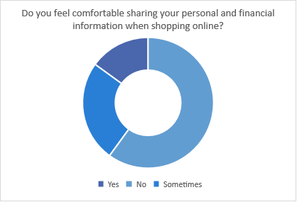

### Reviews and their Influence

65% people told that reviews do play an important affect in their decision making and help them get a good overview of what to expect. On the other hand, we also got 25% responses who told that reviews were not important. The rest were neutral.

### Payment Methods

Majority of the people prefer cash on delivery and won’t choose online methods like credit card when ordering online.

### The Sold Up Effect

Here, we got mixed opinions where some people feel like they fast selling products affect their purchase decisions. While other feel no affect.

### Buying Over Budget

Most people said that if the product Is good enough, they could even buy them over budget.

### Website Appearance

Most people expressed that the appearance of the website does matter where nearly 65% people said in favor of it.

### Recommendations and their Effect

70% of the people expressed positive opinions about getting recommendations from friends and family.

# **Findings**

Upon analyzing the responses and comparing the statistical graphs and figures we can see a pattern of the buying habits of the people. We have found that:

* On average people tend to buy products online from mega sales, but not everybody chooses this potion every time. The overall in youth this trend is higher than other people of older age brackets.
* Most of the people shop online because they find it comfortable not to get up to go anywhere and still get their desired product while sitting at home. Moreover, getting the option to compare wide number of products and their prices without the need to wander around in the malls is also a plus point.
* For a lot of people purchasing power does play an important role and effect in their shopping decisions. Although this can’t be said for nearly everybody.
* Most people don’t find it regretful after buying from online sales. This can be because people tend to buy products in online sales which they like comparatively more. Although, some people do feel pressurized because of online sales. On the other hand, the people who don’t feel this pressure tend to buy more to get value for money.
* Young people usually don’t have many strategies to avoid overspending during such events. On the other hand, elder people express to only buy when needed and not overspent and get out of budget.
* Most people feel a lot of joy in buying from online sales and they tend to get anxious about their orders.
* People in Pakistan don’t prefer to buy using credit cards and other online methods. Instead, they prefer to use the cash on delivery option. This can be because of the lack of trust.
* Majority of the people in Pakistan don’t like to share their information to websites even for marketing and sales purposes.
* Recommendations from friends and family do play an important role in our society when considering a product.
* The overall design and user interface of a website is termed as important by people who visit these online stores.

# **Theoretical Frameworks**

The nature of the questions in this research corresponds broadly to the **Behavioural** and **Cognitive** school of thought.

Shopping online includes a variety of psychological aspects such as attention to stimuli, perception, storing and processing information and deciding. The above-mentioned phenomena are a part of the Cognitive school of thought.

The **cognitive approach** emphasizes the role of mental processes in shaping how we make decisions, including how we weigh the pros and cons of different options and how we choose among them. Shopping online involves the same mental processes that require conscious thinking flow, assessment and appraisal. When making a purchase, all customers develop an understanding of the offerings through their cognition and gauge the feasibility of the purchase. This process of discernment is a core concept of the Cognitive school of thought.

**Behavioural approach** is also inline with the concept of online shopping based on the effect of group behaviour in decision making. This approach is based on the idea that behaviour is a result of environmental stimuli and their associated consequences. Online reviews of products are an integral part of the purchasing process. Reading reviews and ratings and shaping your purchase decision is a good example of behaviourism.

Similarly, peer influence is another factor that largely plays into customer purchases. In today’s digital age of sharing and posting personal information, every individual is constantly comparing himself/herself to someone else. This gives rise to peer influence and greatly influences what people want to buy on the internet.

Some sub-approaches like marketing psychology are also applicable to the scope of our research. However, cognitive and behavioural approaches are the biggest match with the nature of our research.

# **Annexure**

Link to Survey: <https://forms.gle/XjjtFMxKYvdGDLqW7>

* Socio-psychological approaches become prominent in description of the behaviors of online consumers.
* Socio-psychological theories are based on the studies carried out by Fishbein (1963) and Fishbein and Ajzen (1975)

References

Thanks to CZone for Forwarding our survey: [https://www.czone.com.pk/](https://www.czone.com.pk/%C2%A0)

The effects of psychological factors on online consumer behavior - <https://www.researchgate.net/publication/241626159_The_effects_of_psychological_factors_on_online_consumer_behavior>